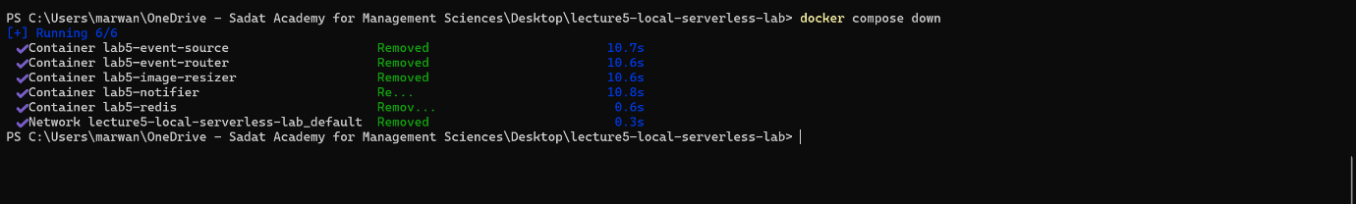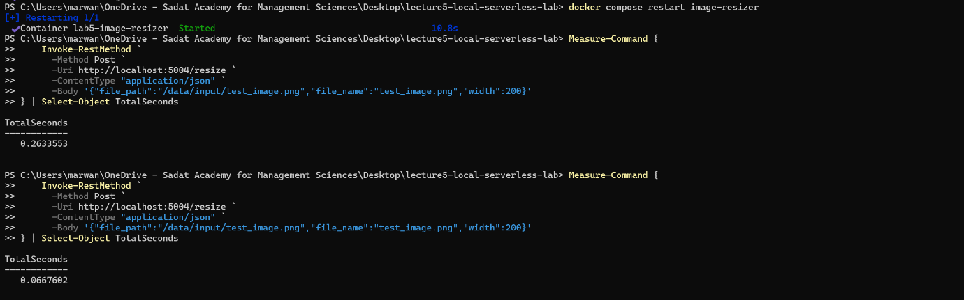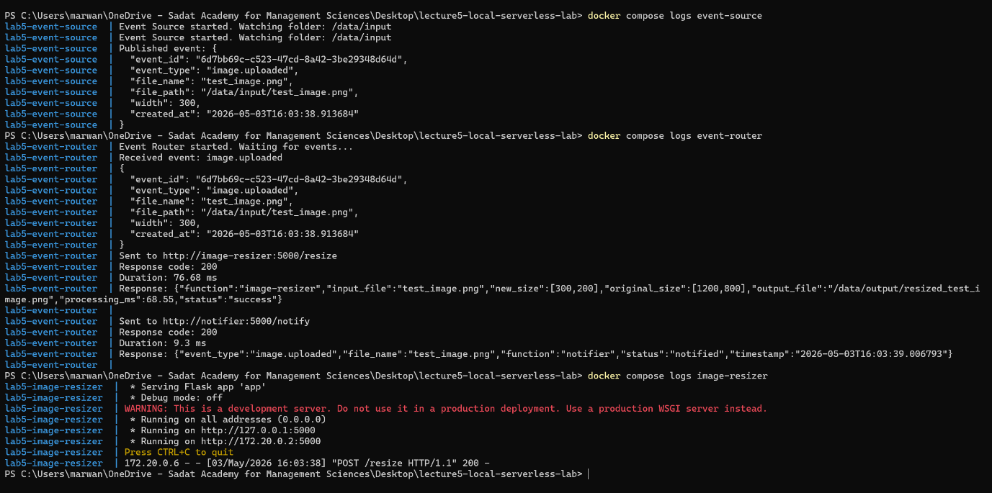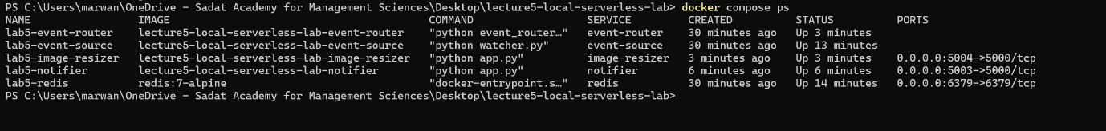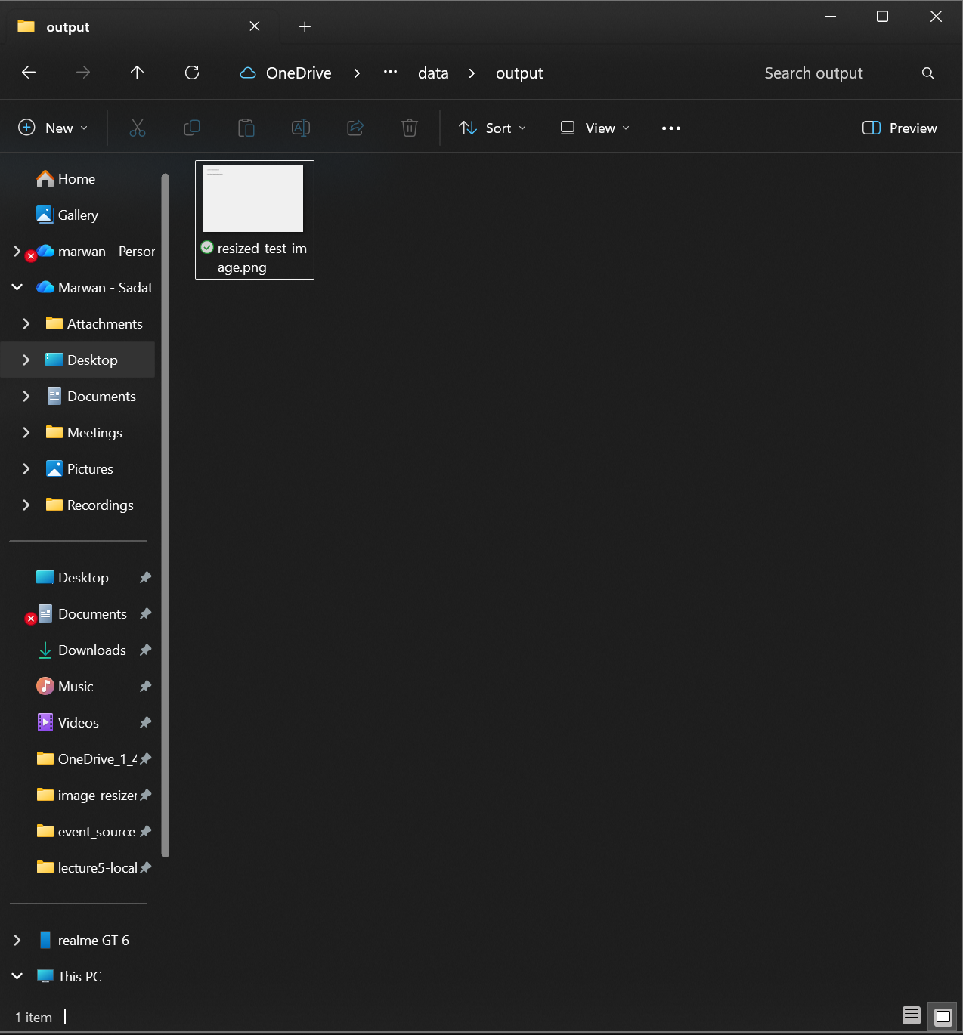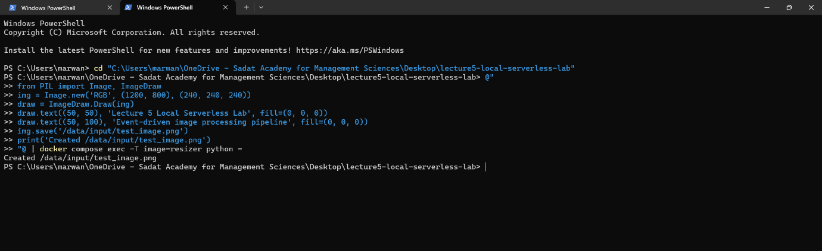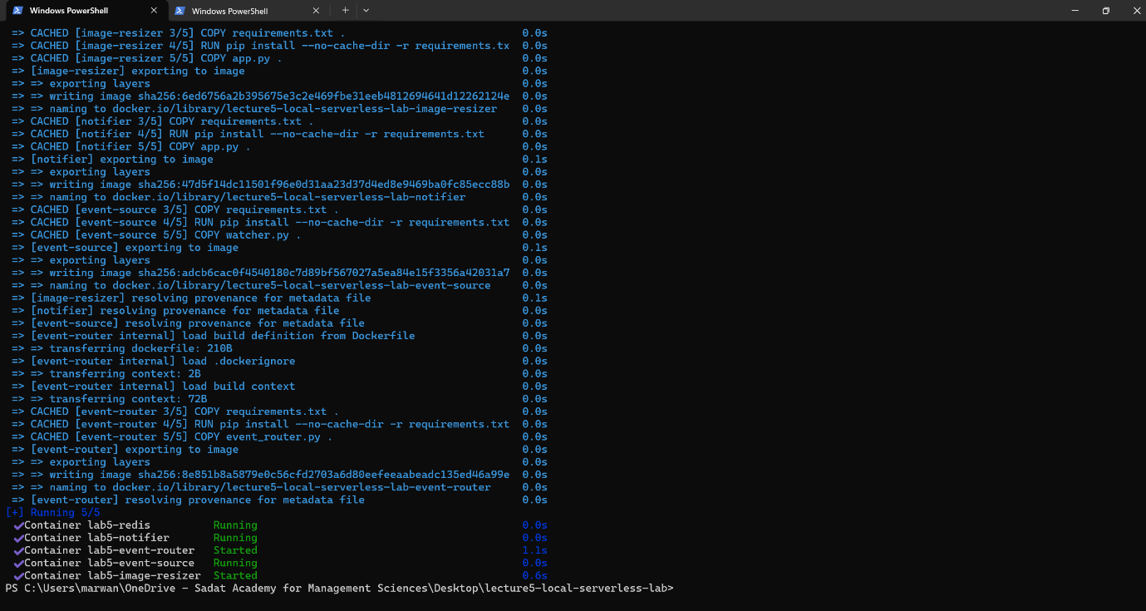

Measurement | Value
Warm request time | 0.0667 seconds (66.7 ms)
First request after restart | 0.2633 seconds (263.3 ms)
Difference | 0.1966 seconds (196.6 ms)
Reason / explanation | The first request takes longer because the container environment and the Python/Flask application must initialize, load libraries into memory, and establish network routing. Subsequent requests reuse this "warm" environment, processing immediately.

1. What is the event source in this lab? It's the watcher.py script. It keeps an eye on the input folder and publishes an event to Redis the moment a new image drops in.
2. What is the event router? It's the event_router.py script. It acts like a traffic cop—it reads the events from Redis and forwards them to the right functions.
3. What are the event destinations? The destinations are our two Flask mini-apps: the image resizer and the notifier.
4. Why is this pipeline loosely coupled? Because the pieces don't rely on each other to work. The watcher just drops a message into Redis and walks away. You could completely delete the resizer, and the watcher wouldn't crash or even notice.
5. What happened after restarting the image-resizer container?
That very first request took noticeably longer to process than the ones that came after it.
6. How is this similar to serverless cold start? In a real cloud, if a function sits idle, the provider spins it down to save resources. When a new request comes in, it has to boot back up from scratch—causing a delay. Restarting our local container perfectly mimicked that exact boot-up delay.
7. What is missing compared with real cloud serverless platforms? We are missing the automated "magic." Real platforms automatically scale up when traffic spikes, handle security, and manage the underlying infrastructure for you.
8. How could this pipeline be extended to support image moderation, OCR, or ML enrichment? It's super easy: you just build a new container for the new task (like an OCR reader) and add its web address to the router's list. The router will start sending the image event to your new tool alongside the others.

